PROGRAM
import cv2
image = cv2.imread("flower.jpg")
if image is None:
print("Image not found")
else:
cv2.imshow("Original Image", image)
blurred_image = cv2.GaussianBlur(image, (15, 15), 0)

cv2.imshow("Gaussian Blurred Image", blurred_image)

cv2.waitKey(0)
cv2.destroyAllWindows()
COMMANDS USED
cd Desktop
cd opencv
python image_blur.py
INPUT
The input image used in this experiment is:
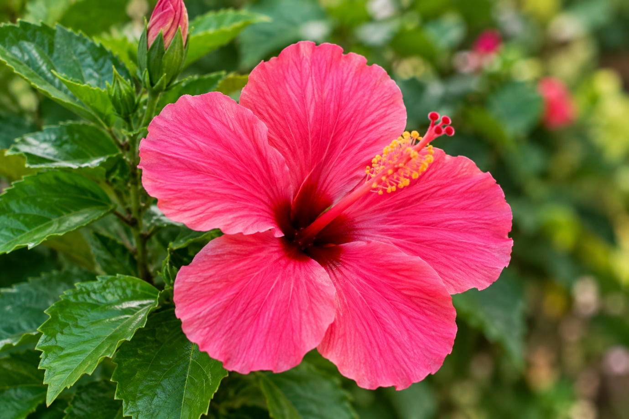flower.jpg
OUTPUT
The program displays two windows:
- Original Image
- Gaussian Blurred Image
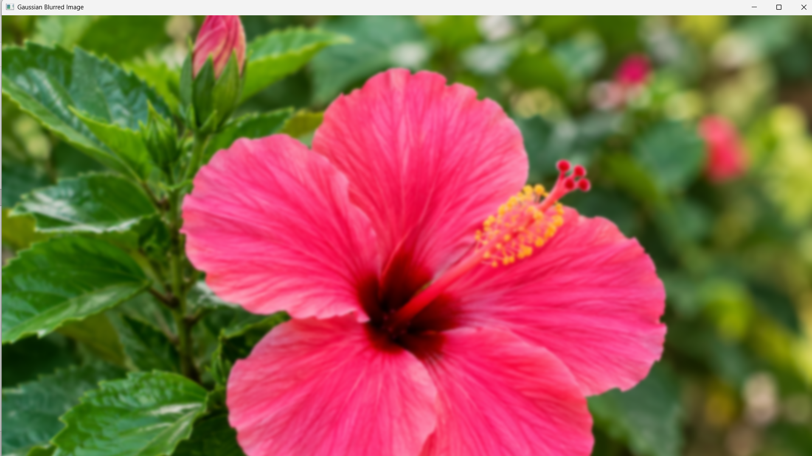
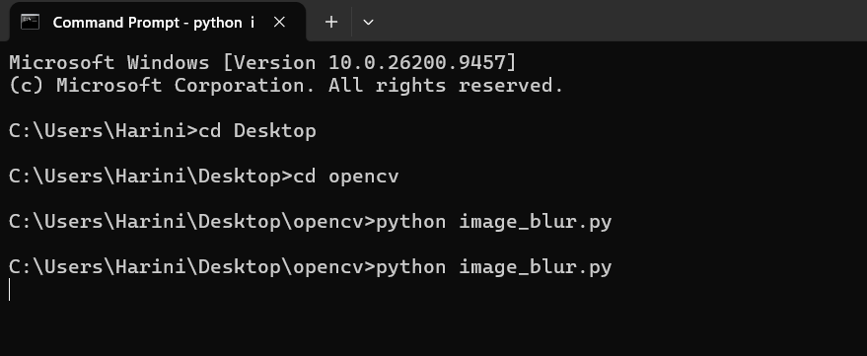

RESULT
Thus, the given image was successfully read using Python and OpenCV, and Gaussian Blur was successfully applied to produce a blurred image.

